Gridless Wireless Network  
Requirement Specifications

**Team name**:

Off the Grid

**Team members:**

Ian Schneier

Linda Palacios

Weikang Zhang

Xucheng You

Jingwen Luo

Alec Motazedi

**Project Sponsor:**

### Prof. Alan Mickelson

### 

## ***Introduction***

### ***Purpose***

This document will introduce the overview description of the system along with specific marketing and engineering requirements as well as the product’s use cases. The document is intended for engineers, product users, and investors who are interested in the product design and would like to dive deeper in the product’s functions, requirements and assumptions that the design is based on.

### ***Scope***

In face of imminent natural disaster, network grids have a high probability of failing, so will cell phone and internet connections. It then makes it difficult for rescue teams to know who and where people need rescuing. In these critical situations time is of the utmost importance, and if rescue teams spend more time trying to locate victims instead of rescuing them, more people are put at risk. Thus, it is important to implement an emergency network to establish a way of communication between victims and rescuers.

The Gridless Wireless Network (G.W.N) provides an emergency network to communities that have suffer infrastructure damage caused by natural disasters. When the normal means of communication fails, G.W.N can be deployed and accessed by victims in the surrounding area. G.W.N is composed of multiple units that works like a mesh network system. The base unit resides in a safe environment and is directly connected to the internet while other units are set to bridge mode and are distributed strategically to provide coverage to the affected area. Because of the area conditions, each unit will be hermetically sealed and reinforced, making it waterproof and able to withstand physical trauma . The goal of G.W.N is to provide victims and rescue teams a reliable smart network, able to relay user locations to better increase mission success.

### ***Definitions, Acronyms, and Abbreviations***

GWN: (pronounced “Gwen ”) The Gridless Wireless Network is the entire network system composed of multiple connecting units.

### ***Overview***

The G.W.N device provides an emergency Wi-Fi network in situations where established network communication systems are inoperable or not present. It transmits a 2.4 GHz signal to the surrounding area, which individuals can connect to using a smartphone or other wireless devices. G.W.N device is supposed to last the average duration to immediately recover from an area which is approximately 72+ hours. In addition, the device is drop proof, waterproof, and portable so a user could take it into a disaster area in a backpack and easily deploy it wherever the person decides.

## ***Overall Description***

### ***Product Perspective***

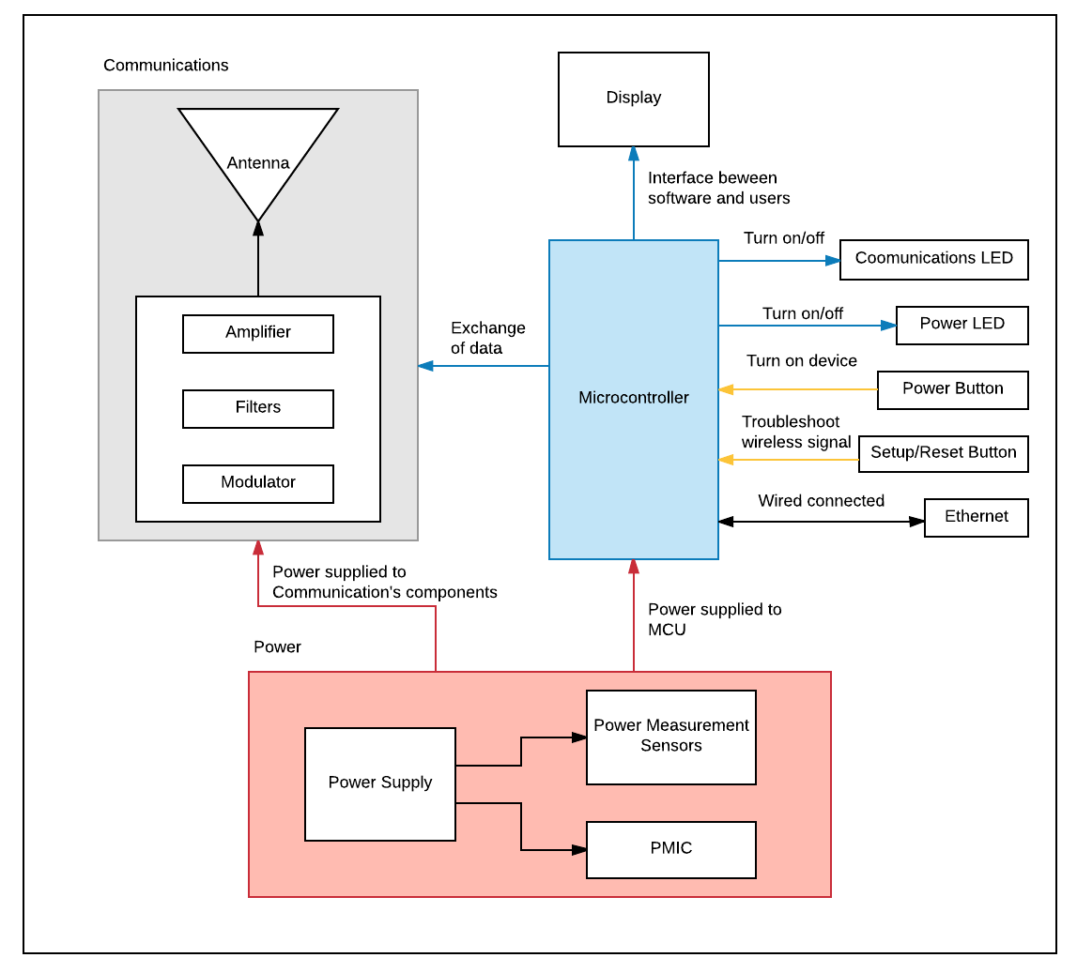

PMIC : Power Management Integrated Circuit

MUC: Microcontroller

### ***Product Functions (priority order)***

This section describes the features of the product, in priority order.

*High Priority*

1. The G.W.N device will provide a WLAN network in areas experiencing emergency situations.
2. The G.W.N device will operate solely on a battery power for a duration of 72 hours.
3. Each G.W.N device must have two modes, base mode and bridge mode.
   1. If the device is set to base mode, it must be physically connected to the Ethernet, so it can share the internet connection with other nodes within range.
   2. If the device is set to bridge mode, it must be place within range of base node to acquire internet connection.
4. Smartphones and other Wi-Fi enabled devices should be able to connect to the wireless network emitted by device.

*Medium Priority*

1. The G.W.N device will be able to locate itself and share coordinates for easy recovery.
2. The enclosure design will make the device portable and rugged enough to deploy in areas affected by disasters.
3. Network will share the location and information of major events in area (aftershock, roadblocks, floods, etc.).

*Low Priority*

1. Extend battery life to more than 72 hours.
2. G.W.N device will share the user’s location so rescue units can access them.
3. By connecting to the network the users can share maps, and images of the environment.

### ***User Characteristics***

|  |  |
| --- | --- |
| User | Rescue units |
| Responsibilities | Two G.W.N devices will be needed. The disaster relief unit has to turn on both devices and make sure power led is on. One device will be set to base mode and must be physically connected to the Ethernet in an outside area not affected by disaster. The other device will be set to bridge mode and deployed at the area affected by natural disaster. Once infrastructure is restore, unit has to recover devices by accessing devices’ geolocation |
| Success Criteria | Network infrastructure is restore |
| Involvement | The system will provide location of individuals connected to the network who are trapped or otherwise need help. At the same time, people who are connected to the network will be able to access specific internet services (determined by how much bandwidth is required) |
| Deliverable | Users access internet and provided applications |

### ***Design Constraints***

* The transceiver will only operate at 2.4GHz frequency that is part of the ISM band (Industrial Scientific Medical)
* The G.W.N device is intended to be portable enough to be stored in a backpack so the dimensions and total weight will be constrained in order to ensure that possibility
* The size of the energy storage unit and therefore the overall battery life of the device will be limited by the size of the enclosure
* Opening the enclosure and accessing the internal electronics may not be possible without permanently damaging the case or compromising its ability to be waterproof

### ***Assumptions and Dependencies***

* + 1. Assumptions
* 72 hour battery life only possible if the device is fully charged upon deployment
* The range of the network signal may be less due to weather, terrain, buildings, and competing signals
* All parts used are assumed to be solid state or non-moving
* Battery will be main source of heat dissipated in device
  + 1. Dependencies
* One G.W.N device has to be connected to an internet network in order to transmit it through the mesh network.
* Multiple GWN devices need to be deployed for large scale network to exist

## ***Specific Requirements: Overall Description***

|  |
| --- |
| **Marketing Requirements:**   1. The system should provide internet access to a variety of base station applications at disaster areas 2. The system should provide access to information and services only via the Off-the-Grid wireless network 3. The system should be portable 4. The system should be have a low cost to produce 5. The system should be able to restore communications and access to network resources immediately after natural disasters like, earthquakes, tsunamis, and hurricanes 6. The system should be easy to use 7. Design must be able to provide rural communities with more accessible, resilient, and healthier internet 8. The system should provide the means for common mobile devices to access applications 9. The system should work at low-power 10. The system must provide wide coverage 11. Device must follow FCC restrictions 12. Device must comply with ITU radio regulations 13. Device must comply with IEEE Standards |

### 

|  |  |  |
| --- | --- | --- |
| **Marketing Requirements** | **Engineering Requirements** | **Justification** |
| 5 | The system will operate for a minimum of 72 hours without needing to be recharged | The communication infrastructure needs to be restored within 72 hours period, to increase survival of victims |
| 4 | The costs of developing the system should not exceed $1,500 | This is based on available budget |
| 5 | G.W.N housing will be hermetically sealed (waterproof) and will be able to be released from high altitudes. Waterproofing the device will allow it to function in areas that have/will experience flooding. The device will also be shock-resistant in order to protect the inner components from damage as it drops from high altitudes. | The device will be exposed to outdoor elements and will be need to withstand them |
| 5 | The system should withstand a drop from a height of 5 meters (15 feet) and still operate | If road conditions are not safe or are block, the device can be drop via helicopters to provide communication to any victims that might need rescue |
| 2,7,8,10 | The G.W.N device will have two modes, base mode and bridge mode. Then, the users can connect to Wi-Fi through the bridge node | In a mesh network, one node needs to be physically connected to the Ethernet so that node can share the internet with other nodes within range and achieve a further range between devices and improve data throughput |
| 1,6,7,8 | Software applications will access existing applications that provide Maps, and Messaging | Based on research done on similar devices and technology being distributed now, these applications are the most common used during disasters and daily activities |
| 1,7 | The G.W.N device must include power measurement ability using ADC with voltage and current output from regulator as input. Also having a feedback loop to control amplifier input in order to control transmit power. | While the product is during testing or on-spot, we would have an estimation of our total power consumption in order to improve power system to extend battery life. |
| 3 | The dimensions should not exceed 8” x 8” x 5” | The device must fit under a typical car seat for relief vehicles, and inside a backpack to aid rescue units and disaster survivors who are walking or hiking |
| 12 | The system will operate in the 2.4 GHz ISM frequency band | Frequency 2.4 GHz is the primary band used in houses and commercial business. It has a more desired wavelength than the alternative frequency of 5.8 GHz. |
| 3,5,9 | The system should be power efficient - antennas and other components should not drain the battery life | Our contact suggested that the device should be power efficient to sustain a 72+ hour battery life |
| 7,11,13 | The system will follow Wi-Fi based communication network. IPV4 and IPV6 protocol and use AES-256 encryption to secure our network. | Choose Wi-Fi due to its range, wide bandwidth, and flexibility. IPV4 and IPV6 are standard TCP/IP protocols. |
| 10 | The system will require two types of antennas Omni-directional and Unidirectional antenna | This type of antenna provides better signal for mesh network due to the surface area |
| 11 | The transmission power of the network signal must be between 10 and 30 dBm (1W) | The transmission power value is dictated by FCC regulations. ISM bands are limited to 30 dBm transmission power |

### 

## ***Use cases***

***Use Case 1: Restore Communications***

**Scope:** Wireless Mesh Network Implementations

**Level:** Sub-function Level

**Actor:** G.W.N device

**Stakeholders and Interests:** Rescue units, and disaster victims want to have the ability to restore or establish communications

**Preconditions:** Two devices will be provided to establish communications, base station and bridge mode. The base mode node needs to be physically connected to the Ethernet and bridge mode node needs to be placed within range to establish Internet connection. The user has the responsibility to make sure the device is 100% charged, and the impact mechanism in device has no damage

**Success Guarantee:** During disasters the device power performance will assist with communications for up to two weeks, and will increase coverage during the golden hours of rescue/response (first 72 hours) . Communications will be establish between members of communities and outside world

**Main Success Scenario:**

* G.W.N devices connect with each other and with users as well, creating a mesh network
* The user connects to G.W.N device through Wi-Fi
* Client restores communications with G.W.N devices
* Relief unit can now inspect the area and provide communication to victims trapped inside infrastructure
* Relief unit can communicate back to base to update other units about situation

**Extensions:**

1. One or more G.W.N devices cannot connect to mesh network
   1. Self-healing mode allows the network to automatically find the fastest and most reliable path
2. Fault tolerance

**Special Requirements:** Multiple G.W.N devices need to be active in order to provide wide coverage if not enough users are connected.

**Technology and Data Variations List:** In a mesh network, one node needs to be physically wired to the Internet, this aspect will be a challenge for disaster relief. Adjustments for different radio technologies.

**Frequency of Occurrence:** Could be used daily in rural communities, and up to two weeks during disasters.

**Open Issues:** What to consider when designing a high-traffic network system?

***Use Case 2: Power Management***

**Scope:** Low-power and self-sufficient device

**Level:** Sub-function

**Actor:** G.W.N device

**Stakeholders and Interests:** Users want the communication infrastructure to be restored within the first 72 hours (golden hours), in order for survival changes of victims to increase

**Preconditions:** Device must be charged and Power LED must be on

**Success Guarantee:** The performance of devices should not decay during golden hours, and keep maintaining low-power consumption for a total of two weeks

**Main Success Scenario:**

1. Turn on device
2. Power LED must be on

**Extensions:** The devices maybe use the Solar energy to extend their working hours

**Special Requirements:** Charging station must be provided for rechargeable batteries

**Frequency of Occurrence:** Devices can be used for a period of two weeks

**Open Issues:** If Power LED light is out, what are other ways that we can let user know that device is on?

***Use Case 3: Service Applications***

**Scope:** Variety of services provided to users

**Level:** User goal

**Actor:** Relief units, disaster victims, and rural communities

**Stakeholders and Interests:** Users wants to have to a variety of services in order to send text messages, images and GPS coordinates, receive maps, images and text messages, voice service, and data service. Users would like to inform rescue units that they are trapped inside a collapsed infrastructure or area. Disaster relief organizations would like to have access to an application that allows them to coordinate with one another.

**Preconditions:**  User's device is connected to mesh network.

**Success Guarantee:** User can navigate specific applications according to user's needs

**Main Success Scenario:**

1. User opens application according to needs.
2. User navigates through application and create profile so other users know who are they talking to.
3. User creates a request.
4. Request is accepted.
5. Users can add more users if they want.
6. User signs off.
7. User closes application.

**Extensions:**

1. Messaging application
2. Map application
3. Coordination tool
4. User privacy
   1. Data encryption
5. Application encounters errors
   1. Application sends error to System
   2. Application reports error to user
   3. Application shuts down
6. User encounters application error
   1. System diagnoses error
   2. System fixes error

**Special Requirements:** User has to be connected to G.W.N device

**Technology and Data Variations List:** User's device requires Wi-Fi capability

**Frequency of Occurrence:** As long as user is connected to mesh network via Wi-Fi

**Open Issues:** What types of applications are already in the market that can be used in wireless mesh networks?

***Use Case 4: Quick Deployment***

**Scope:** Quick Deployment during disasters

**Level:** User goal

**Actor:** Relief units

**Stakeholders and Interests:** Relief units would like to deploy device as soon as possible to regain communications

**Preconditions:** Device has been inspected and there are no noticeable damages. Power LED light is on.

**Success Guarantee:** All internal components have not been damage due to deployment and connection has been established

**Main Success Scenario:**

1. Rescueunit deploys G.W.N device
   1. Via airdrop
   2. Carrying by personnel, inside backpack or vehicle
2. Device lands in location with no damage
3. Users can connect to nearby device

**Extensions:** *If device has taken damage, signal from device will be lost and software will perform “self-healing”, network will automatically find the safest and fastest path to send data

**Special Requirements:** Device has no damage

**Frequency of Occurrence:** Device will be deploy once during emergency and recovered once infrastructure has been established

**Open Issues:** How should users dispose of device if damage? Can users get a hold of parts to repair device?